# Assignment Set 3

## Assignment on Dependency - Level 2

A telecom company wants to generate reports on the call details of the customers. Each customer can make multiple phone calls.  
  
**Problem Statement:**The parse_customer method takes a list of Customer objects and a list of CallDetail objects. For every customer, identify all the corresponding Call Detail objects ( the customer phone number and the phone number of Call detail object have to match ), add them to the list_of_calls of corresponding customer object and add the updated customer object to list_of_customer_calldetail_objects of Util class.

1Fail: \**was failing due to my ERROR CHECK - if(len(temp)!=0:*

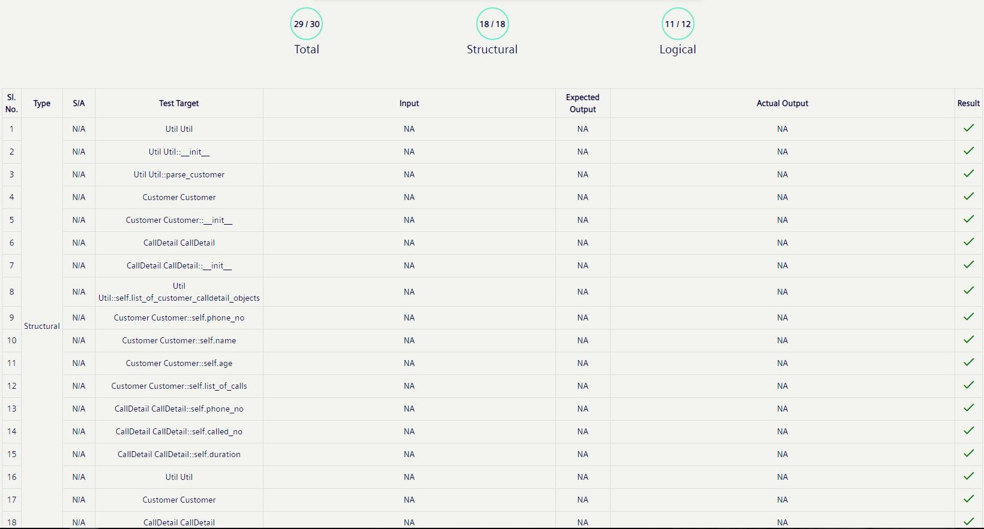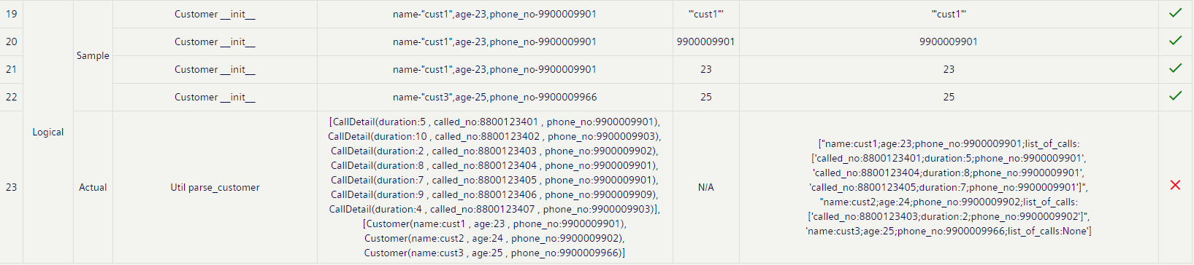

All Pass:

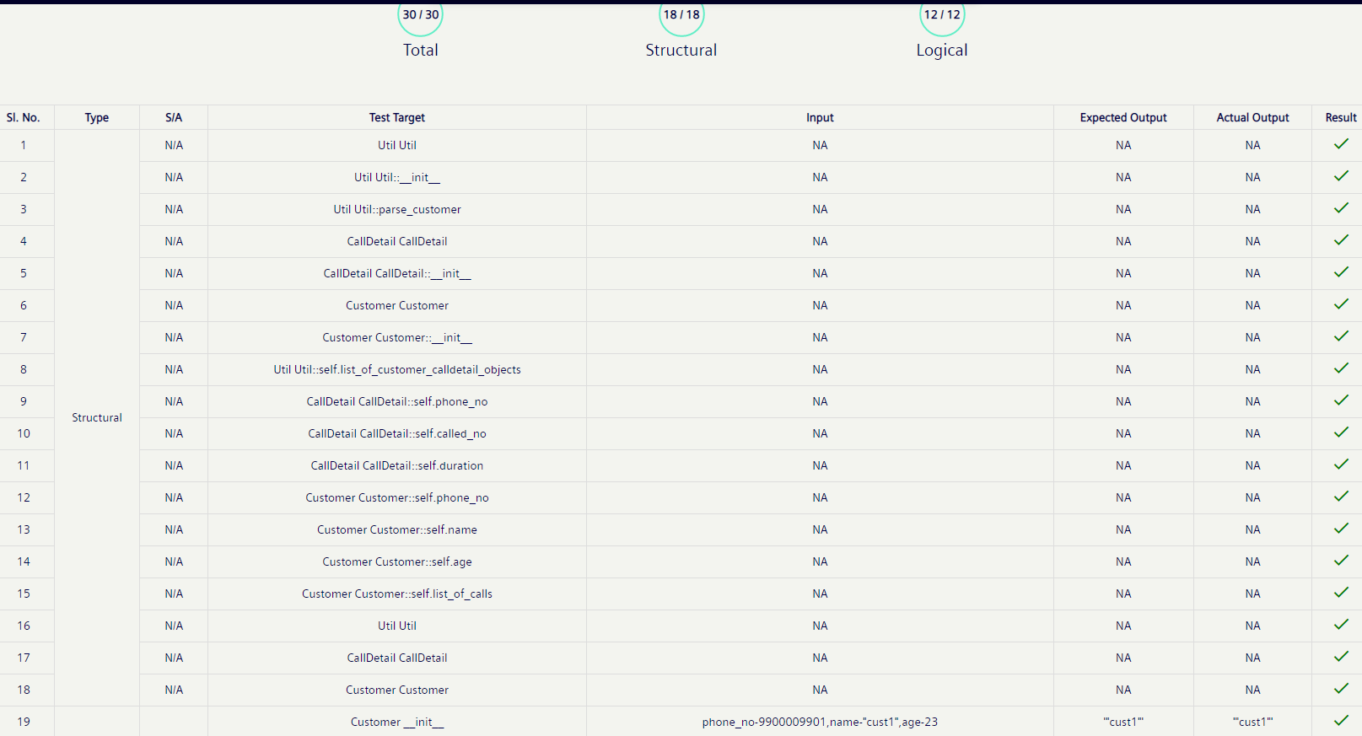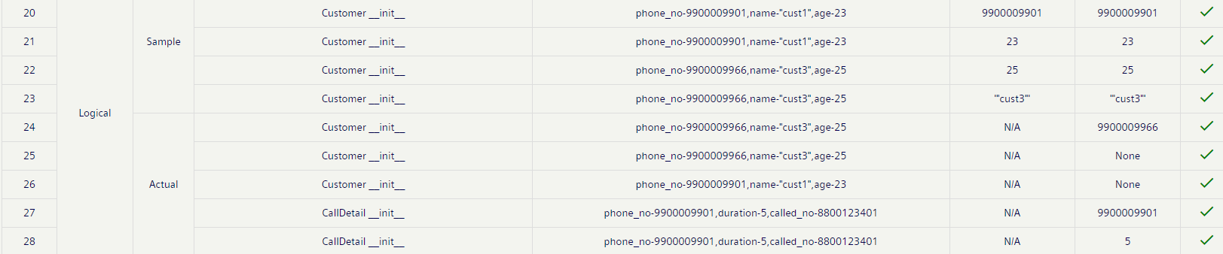

## Assignment on Aggregation - Level 2

Freight Pvt. Ltd, a cargo company, forwards cargos/freights between its customers.  
Freight charges are applied based on weight and distance of the shipment.  
Write a python program to implement the class diagram given below.

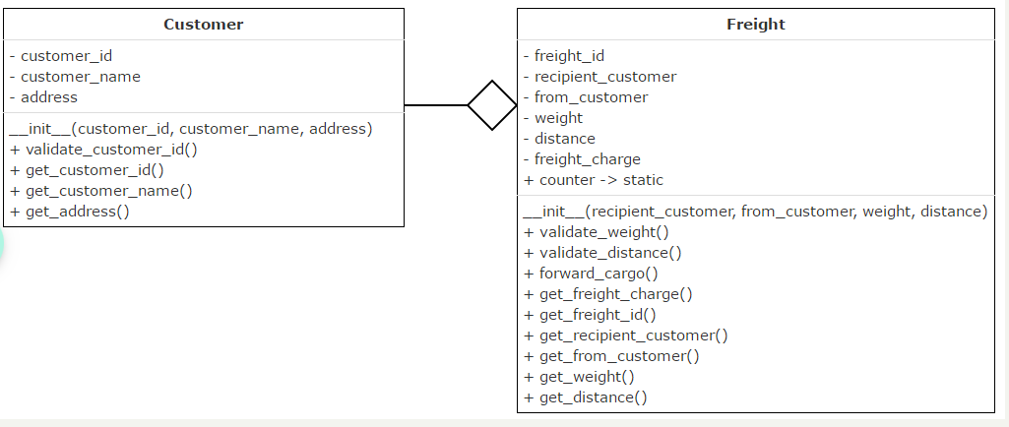

**Method description:**

1. Initialize counter variable to 198 in Freight class
2. All validate methods should return true, if validation succeeds. Else it should return false
3. **validate_customer_id():** Customer id should be 6 digits and should begin with digit 1
4. **validate_weight():** Weight should be a multiple of 5
5. **validate_distance():**Distance should be between 500kms and 5000kms (both inclusive)
6. **forward_cargo():**
   * Validate from_customer.customer_id, recipient_customer.customer_id, distance and weight of the freight
   * If valid,
     + auto-generate freight_id starting from 200 and initialize it. freight_id should be even
     + calculate freight_charge based on weight (Rs.150/kg) and distance (Rs.60/km)
   * Else, set freight_charge to 0

**For testing:**

* Create objects of Customer and Freight class
* Invoke forward_cargo() method on Freight object
* Display freight id and freight charge
* In case of error/invalid data, display appropriate error message

All Pass:

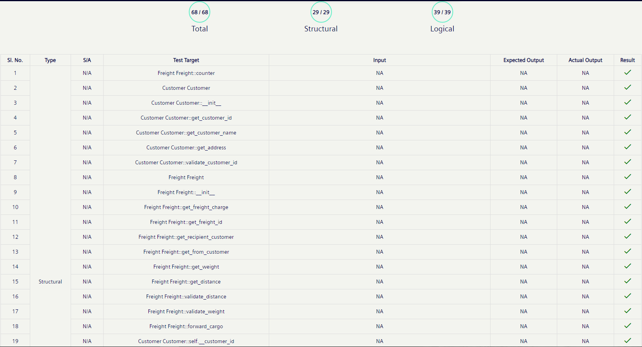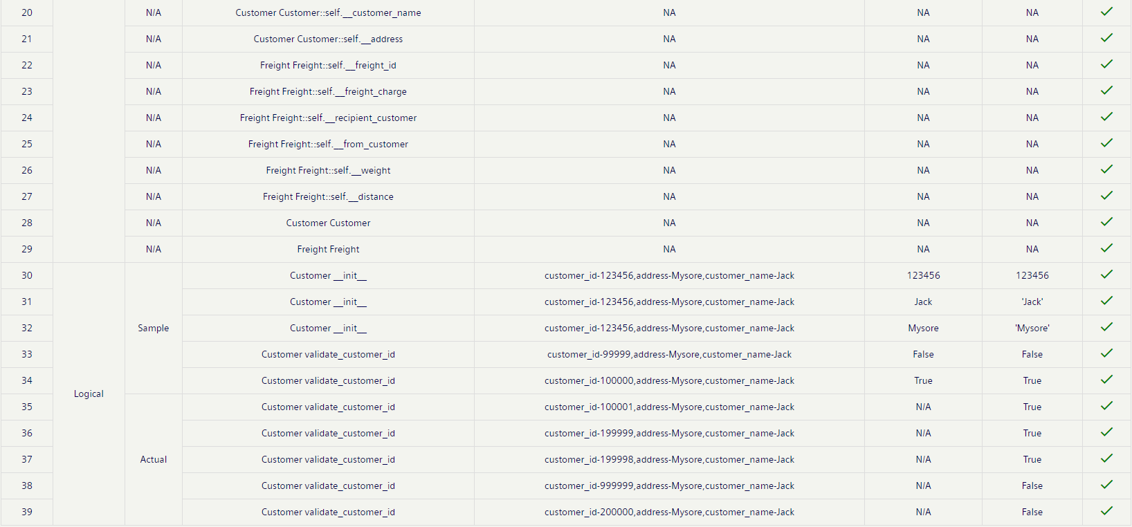

## Assignment on Dependency & List Objects - Level 2

In the retail store scenario, let's look at the portion of customer purchasing items from the retail store.

Write a python program to implement the class diagram given below.

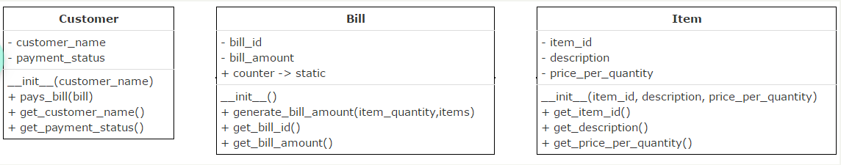

**Class Description:   
Bill class:**

1. Initialize static variable counter to 1000
2. **generate_bill_amount(item_quantity,items):**Calculate bill amount based on the items purchased by the customer
   1. Accept a dictionary, item_quantity which contains the item id (key) of the items purchased along with the quantity (value)
   2. Accept a list, items which contains the list of Item objects available in the store
   3. Generate bill id starting from 1001 prefixed by "B" and initialize attribute, bill_id. Ex. "B1001", "B1002" etc.
   4. Calculate bill amount based on the quantity and price of the items purchased by the customer
   5. Set attribute, bill_amount with the calculated bill amount

Assume that values in item_quantity and items are always valid.   
**Customer class:**

**pays_bill(bill):**Pay bill based on the bill amount

1. Accept Bill object which contains the details of the bill to be paid by the customer
2. Update attribute, payment_status to "Paid"
3. Display customer name, bill id and bill amount

**Note:** Perform case insensitive string comparison  
  
**For testing:**

* Create objects of Customer class, Item class and Bill class
* Invoke generate_bill_amount(item_quantity,items) on Bill object by passing the dictionary containing item_id and quantity of items purchased by the Customer and list of Item objects
* Invoke pays_bill() on Customer object by passing the Bill object

Initial Verification:

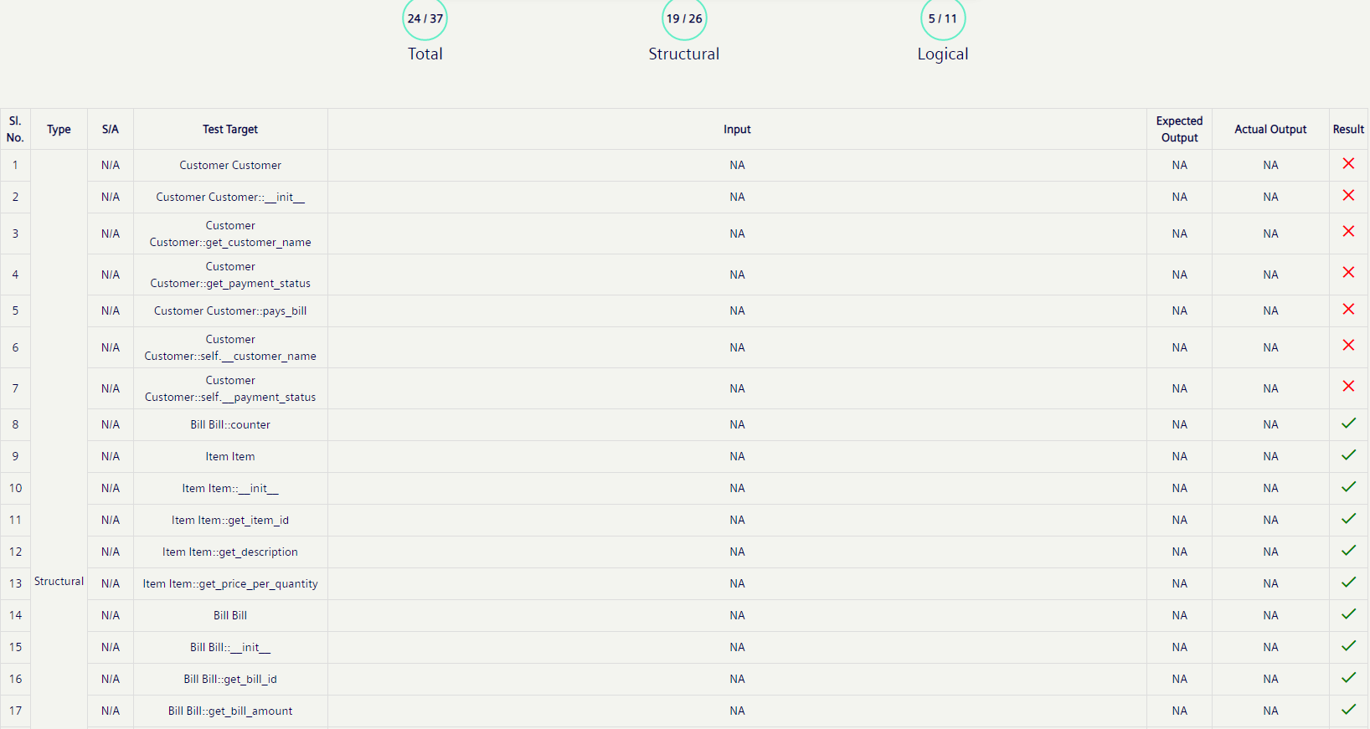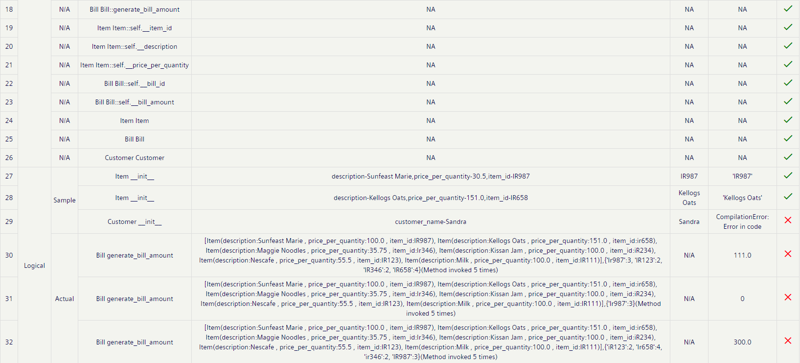

Debugging:

* Bill generate_bill_amount test case passed after adding “if(key.upper()==item.get_item_id().upper()):” since ***case insensitive*** string comparison

Still Below test cases failing:

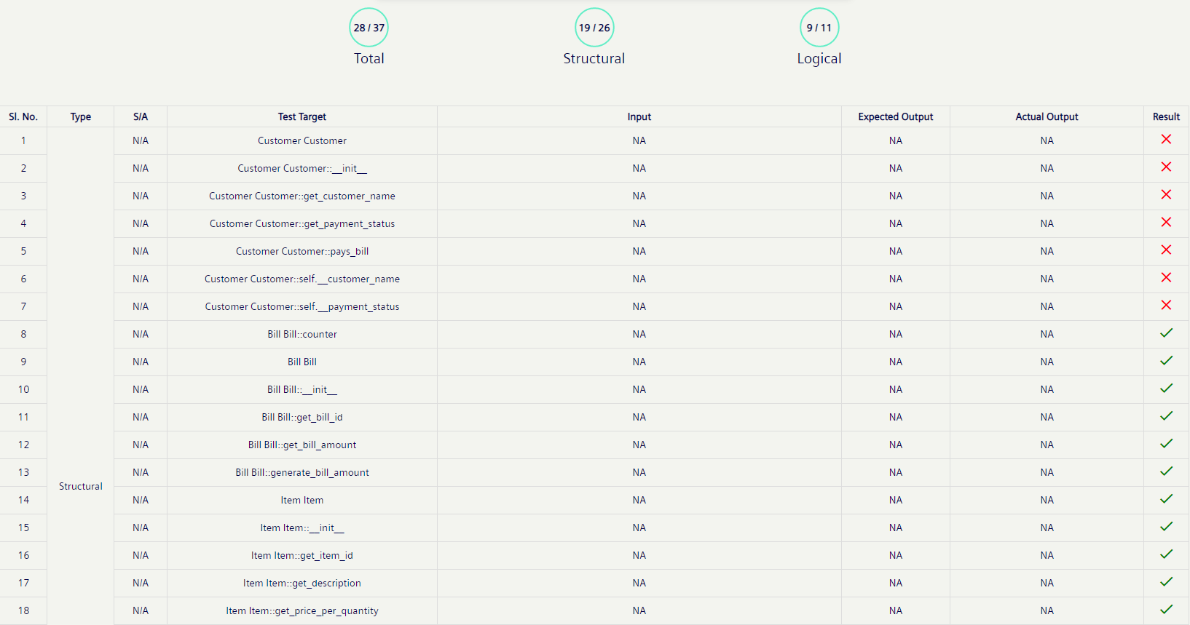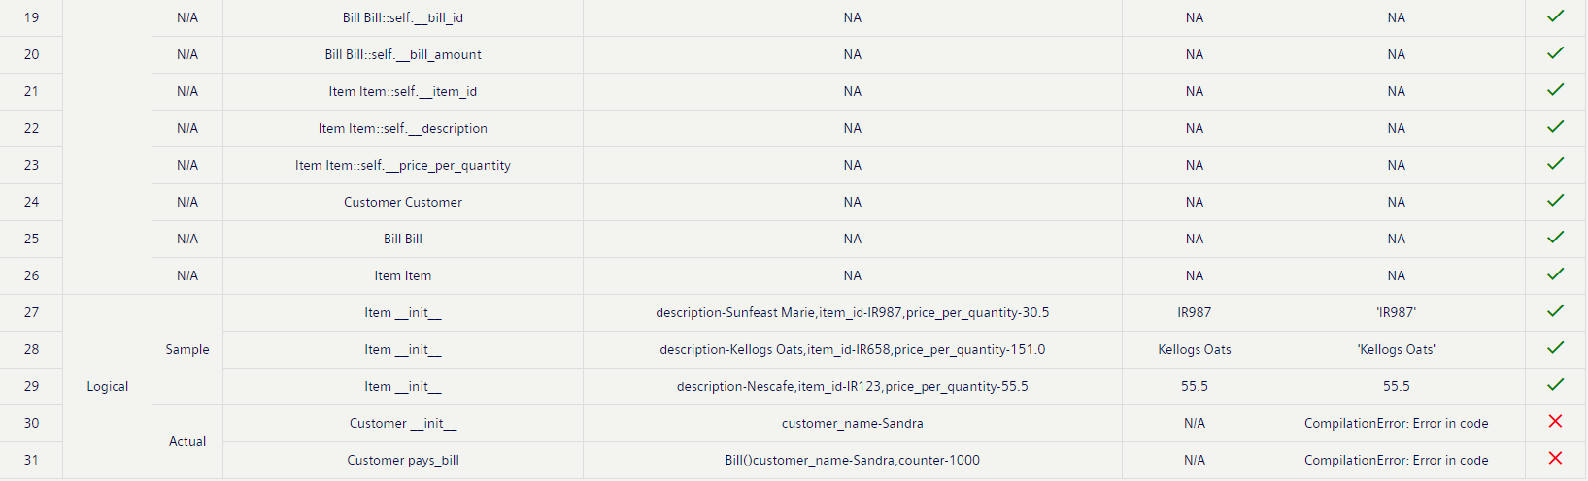

## Assignment on Static Counter - Level 2 [Repeated]

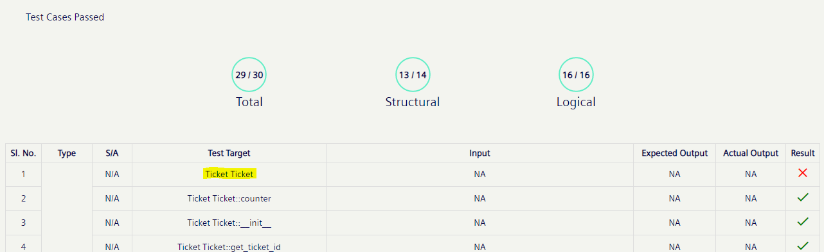

*What is the above Testcase checking for?*

## Assignment on Static - Level 2

"Infinity" IT solution wants to automate their recruitment process. They have decided to accept 5 applications for each of the three job bands ("A", "B" and "C") in the company.

Write a Python program to implement the class diagram given below.

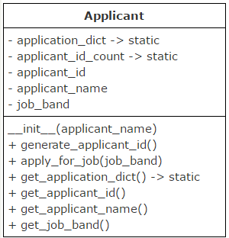

**Method/Attribute description:**

1. Initialize static variable, applicant_id_count to 1000
2. **application_dict:** Dictionary which store application count (value) for each job band (key)
3. **generate_applicant_id():** Auto-generate applicant id starting from 1001 and initialize attribute, applicant_id
4. **apply_for_job(job_band):** Accept the job band for which the applicant is applying.
   1. Check if application count for the applied job band has reached the maximum limit, 5. If so, return -1.
   2. Else,
      * increment application count for the applied job band by 1 in the dictionary
      * generate applicant id and
      * initialize attribute, job_band with the applied job_band

**For testing:**

* Create objects of Applicant class
* Invoke apply_for_job(job_band) method on Applicant object by passing the job band for which applicant is applying
* If application is accepted, display applicant id, name and job band
* Else, display appropriate error message

Verification:

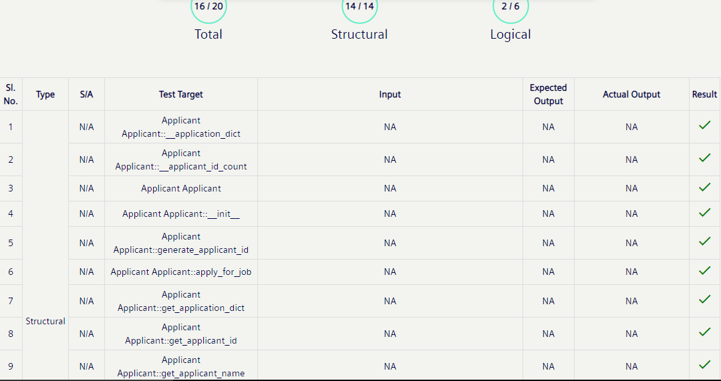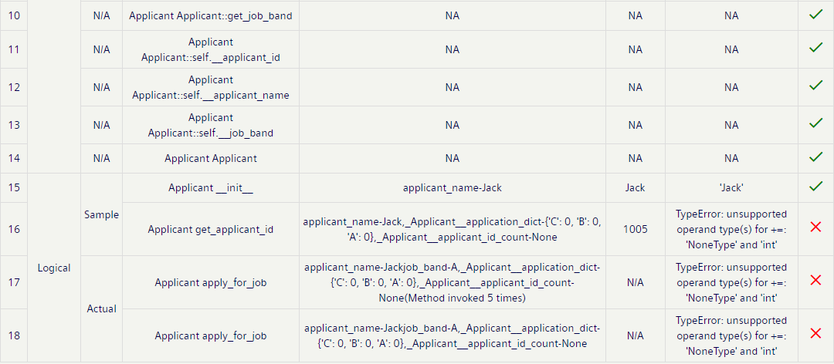

*** All test cases were failing earlier due to the print statement in else: of the method – “def **apply_for_job**(*self*,job_band):”

Still some test cases ; check later.

## Assignment on Dependency & Static - Level 2

Care hospital management wants to calculate the charge of lab tests done by its patients.  
Write a python program to implement the class diagram given below.

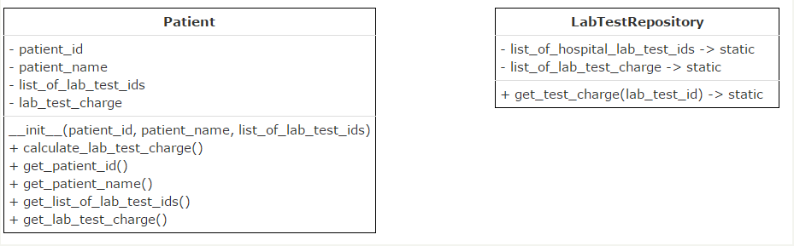

**Class Description:  
LabTestRepository class:**

1. **list_of_hospital_lab_test_ids:** Static list which contains the list of test ids of lab tests available in the hospital
2. **list_of_lab_test_charge:** Static list which contains the charge of the lab tests available in the hospital
3. The above two lists have one-to-one correspondence
4. **get_test_charge(lab_test_id):** Accept a lab test id and return the corresponding lab test charge. If lab test id is invalid, return -1

**Patient class:**

1. **list_of_lab_test_ids:** Instance variable which contains the list of test ids of lab tests done by the patient
2. **calculate_lab_test_charge():** Calculate total charge of the lab tests done by the patient
   1. Calculate total lab test charge based on test charge of each lab test done by the patient
   2. If any lab test id provided by the patient is invalid, consider its charge to be 0
   3. Initialize attribute, lab_test_charge with the total lab test charge

**Note:**Perform case sensitive string comparison    
  
**For testing:**

* Create objects of Patient class
* Invoke calculate_lab_test_charge() on Patient object
* Display patient name, patient id, test ids of lab tests done by the patient and total lab test charge

Verification: [All Pass]

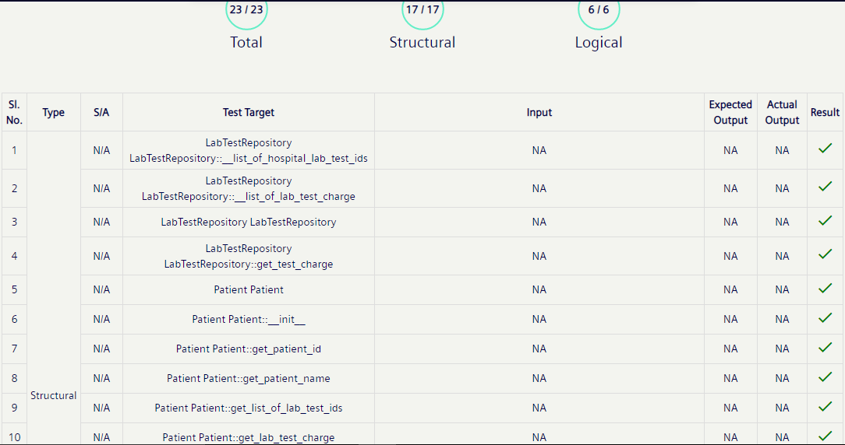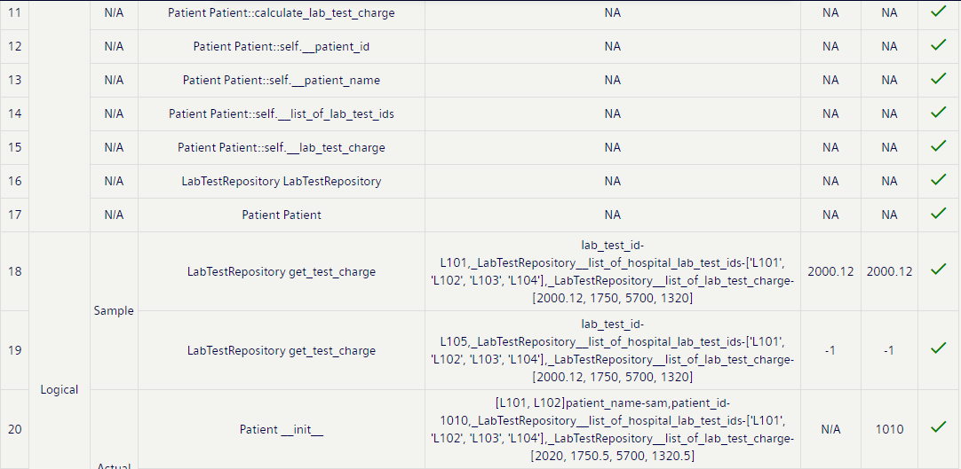

## Assignment on Static List - Level 3

"FairyLand Multiplex" wants to automate ticket booking and seat allocation process.  
Write a python program to implement the class diagram given below.

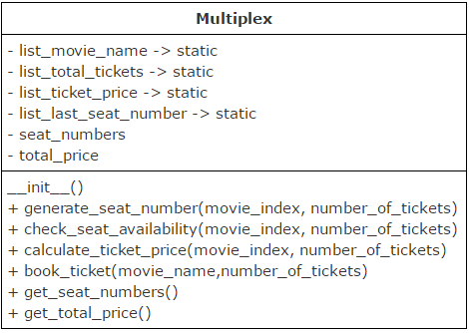

**Assumptions:**

1. Multiplex has two screens having different seating capacity
2. Two movies will be screened everyday (one show/movie)
3. Booking will be opened every day morning for that day’s shows
4. Movie name, total tickets available, ticket price and last seat number allocated for both movies are stored in lists having one to one correspondence. Details of first movie will be available at the 0th index and second movie at the 1st index of these lists

**Method description:**

1. **check_seat_availability(movie_index,number_of_tickets):** Checks seat availability for the given movie. Refer the code given in starter code
2. **calculate_ticket_price(movie_index,number_of_tickets):** Calculates total ticket price for the given movie. Refer the code given in starter code
3. **generate_seat_number(movie_index,number_of_tickets):**Allocate required number of seats for the given movie.
   1. Seat numbers should be auto-generated as mentioned below:
      1. Seat numbers should be generated starting from 1, prefixed by "M1-" for movie-1 and "M2-" for movie 2
      2. Examples movie-1: M1-1, M1-2, M1-3 etc, movie-2: M2-1,M2-2 etc
4. Update total number of tickets available for the given movie in list_total_tickets
5. Update last seat number allocated for the given movie in list_last_seat_number
6. Return the list of generated seat numbers
7. **book_ticket(movie_name,number_of_tickets):** Book tickets for the given movie.
8. Return 0, if movie name is invalid
9. Return -1, if enough tickets are not available for the given movie
10. Else,
    1. Generate seat numbers
    2. Initialize attribute, seat_numbers with the list of generated seat numbers
    3. Calculate total ticket price

Perform case sensitive string comparison.

Verification: [3 test cases failing]

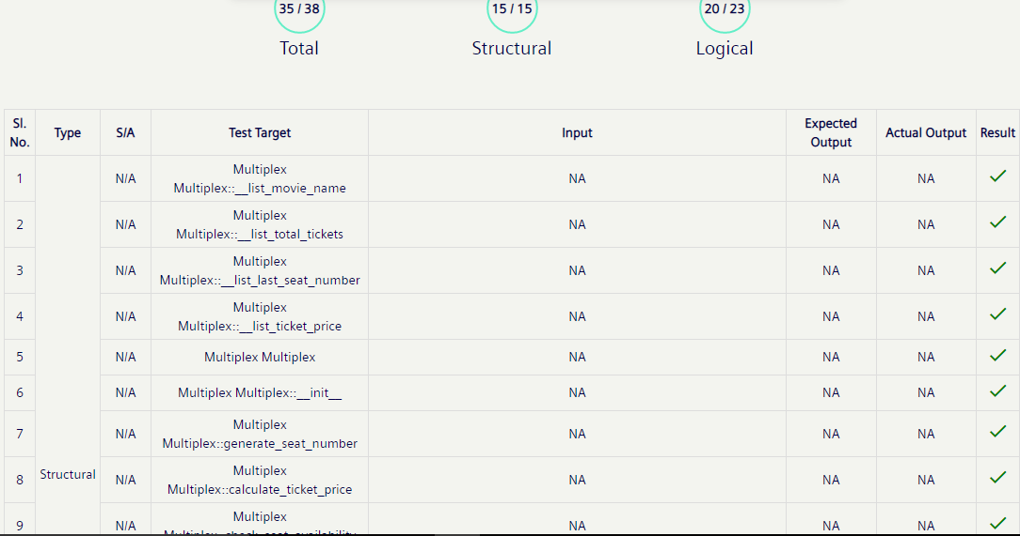

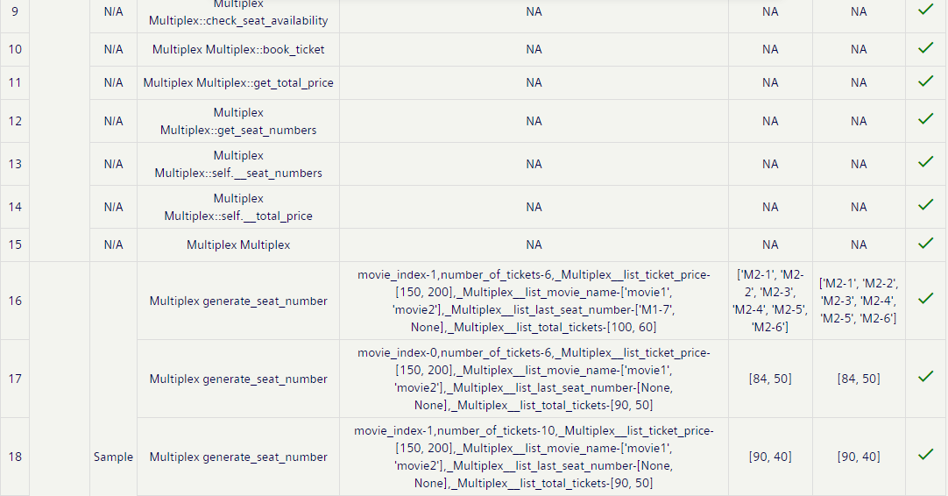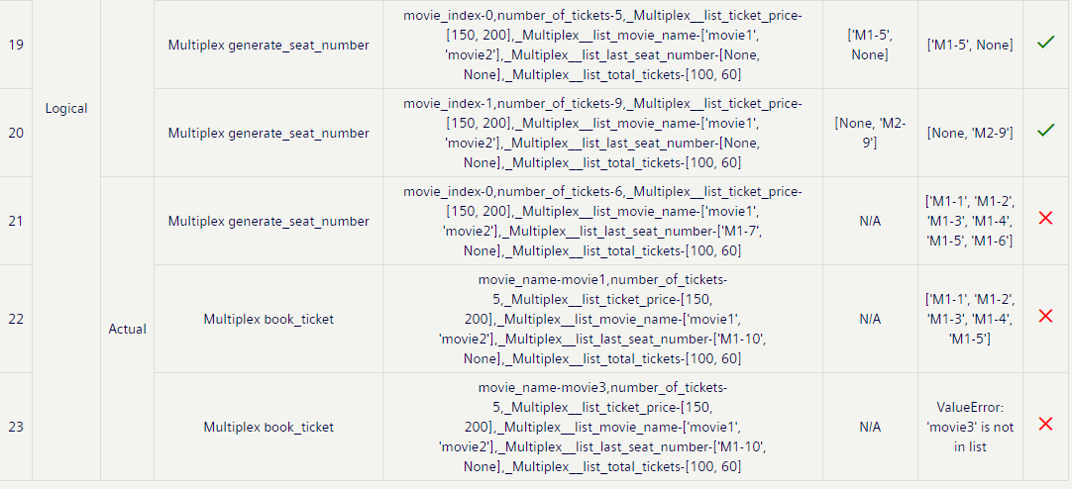

Debugging:

* Removing **movie_index=Multiplex.__list_movie_name.index(movie_name)** passed the last test case-23 as it was Throwing *ValueError: 'movie3' is not in list during runtime* & also bypassing below movie validation.